**EECS 160LA Lab Report**

|  |  |
| --- | --- |
| Title | Lab 5: PI Controller Design for Position Control |
| Day of Session | Friday 8-10:50 am |
| Student Name | Cameron Peterson-Zopf |
| Date of Submission | 11/22/24 |

# 

# Introduction/Objective

In this experiment we utilized pulse input to extract the overshoot percentage, settling time, and rise time of the system for a specific value of system response. Specifically, the pulse input increases from 2 to 4 V square wave, with a duty cycle of 50%, and operating at 50 mHz. A saturation control of +/- 12 V was employed during this experiment, as well as a potentiometer. This analysis was applied to a DC motor’s response, with the controller having both P and PI control. The group also analyzed position control of the circuit, with the group determining what type of control is necessary for obtaining zero steady state error. The input curve, output curve, and controller output curve are graphed and recorded for P and PI control. The potentiometer voltage supplied is 5 V, the saturation control is +/- 12 V, and the DC motor is supplied by 25 V.

# Discussion

For this experiment, the group will use P and PI control. We will construct the following circuit shown in figure 1.

**Figure 1:** Block Diagram of Circuit

The overshoot, settle time, and rise time are computed from the graphs generated on an oscilloscope. The overshoot percentage was calculated by the following formula:

These results were tabulated in table 1.

|  |  |  |  |  |  |
| --- | --- | --- | --- | --- | --- |
| Control Type | Overshoot (V) | Overshoot % | Rise Time (ms) | Saturation Value (V) | Settle Time (s) |
| P Control | 2.19 | 10.606% | 860 | 1.98 | 2.1 |
| PI Control | 2.2105 | 9.50% | 880 | 2.01875 | 2.32 |

**Lab Questions:**

**Question #1:**

*Attach the block diagrams and waveforms from prelab questions 2 and 3. Explain the process of integral windup and why it occurs once actuator saturation is included. How might you counteract the effects of windup?*

**Figure 2:** Block Diagram for Prelab w/o Saturation

**Figure 3:** Waveforms of System Input, Output, and Controller Output w/o Saturation

**Figure 4:** Block Diagram for Prelab w/ Saturation

**Figure 5:** Waveforms of System Input, Output, Saturation Output, and Controller Output

The response time is slightly longer for the system with the saturation block. This is due to the saturation block limiting the amount of voltage that can be applied to the motor. This limitation of voltage in turn will slow down the entire response to the system, including rise time and settling time. The addition of saturation also causes more overshoot due to the saturation prohibiting the controller from getting enough voltage to the motor to cancel out the entire step input. With wind up, the actuator is blocked from giving the adequate response to the system error and creates an overshoot which continues to increase. To get rid of the overshoot, the integrator anti-windup technique can be employed, which adds a feedback loop that feeds back to the integrator state. This loop makes sure that the integrator state is not reset when the saturation is on. It does this by keeping the error input small to prevent it from shooting up while the system is saturated. This action then allows the system not to overshoot.

**Question #2:**

*Calculate the rise time, overshoot, and settling time of the system in Fig. 6 with KP = 100, C1 = 10, and C2 = 0.6s (show calculation steps, do not just put the block diagram into Simulink or MATLAB and measure it).*

**Figure 6:** Block Diagram for Position Control of DC Motor w/ P Control

Figure 7: Hand Calculations of Overshoot, Rise Time, and Settle Time

**Question #3:**

*Based on your scope capture for P control, were the actual rise time, overshoot, and settling time what you calculated (you do not need to measure them exactly, just answer qualitatively)? Explain why or why not. Attach the scope capture of the input, output, and controller output, highlighting the occurrence of saturation in the op amp output.*

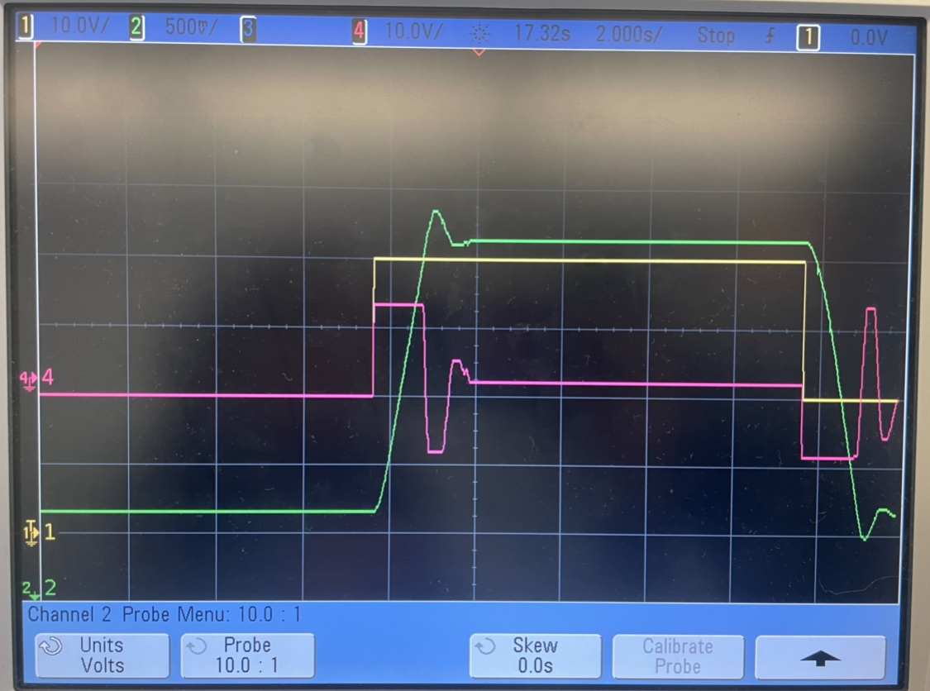

**Graph 1:** P-control graphs. Input is in yellow, controller is in pink, and output is in green.

They were not close to what was calculated. All parameters were significantly lower than the calculated theoretical values. The likely cause was due to the theoretical models not containing the 12 volt saturation limits that were in the experimental model. This creates a constraint on how much the Kp controller can respond to an error. Without saturation this value would cause an overestimation that results in a large overshoot but saturation prevented this from happening which lead to less overshoot and helped the system meet steady state quicker.

**Question #4:**

*What might you change in your P controller to reduce the chances of saturation occurring?*

Saturation can be prevented by lowering the value KPin order to reduce the extent of the response to an error by the P controller. By doing this the response is toned down and as a result there will be less saturation.

**Question #5:**

*Attach the waveforms from the scope of the reference signal, potentiometer voltage, and output of the controller when using PI control. Do you see the effects of integrator windup? Explain why or why not. (Hint: does the op amp integrator continue to integrate once the output saturates?)*

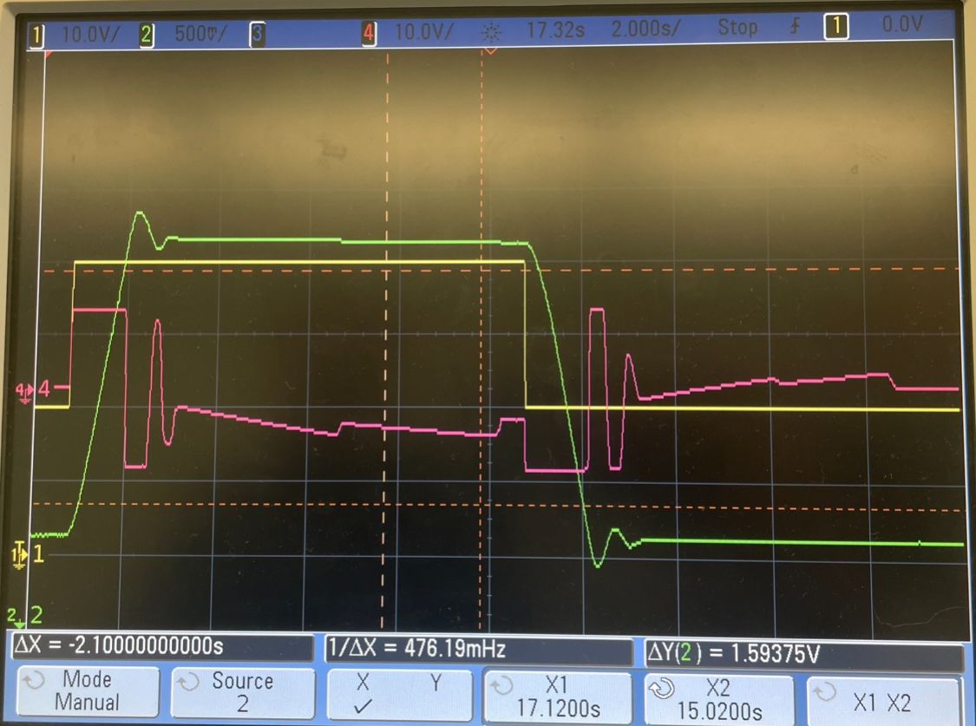

**Graph 2:** PI-control graphs. Input is in yellow, controller is in pink, and output is in green.

The effects of the integrator windup is visible in the PI-control. Once the controller saturates, the op amp continues to integrate, as visible in the pink graph. As a result the controller overcompensates for the error once it is able to respond again resulting in the 2nd large spike which is not visible in the original.

# Conclusion

In this experiment we described how changes in the type of control changes the metrics of a circuit with a DC motor. Specifically, we measured the controller output, system output, and input signals. For the output signal, we measured the settle time, rise time, and overshoot percentage. As expected, the rise time and settle times will increase due to the addition of the integrator, but the overshoot will slightly decrease, and the steady state error has improved. Additionally, the PI controlled demonstrated integrator windup with the additional spiking which was expected. The parameters were analyzed in physical circuits while in lab and through simulations done by MATLAB. The differences between the experimental and theoretical values were determined to be attributed to the 12V saturation in the controller.